 | 

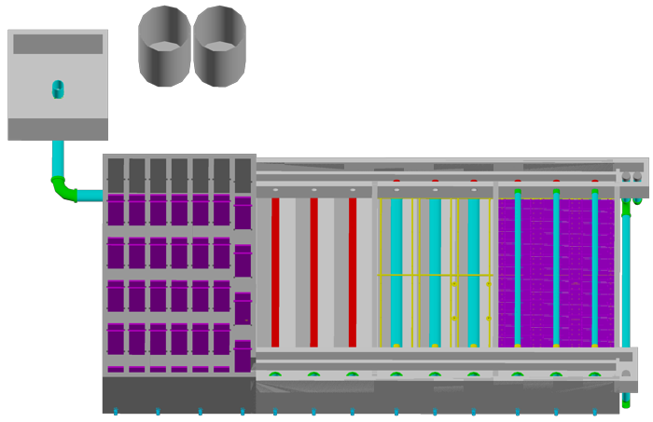

Preliminary design for UI.City UI.State, UI.Country
UI.Name.First UI.Name.Last
UI.Organization
Copyright © 2010 Cornell University
Table of Contents
Disclaimer 3
Permission and Licensing Information 3
Introduction to AguaClara 4
The Technology 4
Chemical Doser 4
Chemical Dose Controller 4
Rapid Mix 10
Flocculation 10
Vertical Flocculator 11
Horizontal Flocculator 13
General Flocculation Design 14
Sedimentation 15
General Description 15
Maintenance 15
Input Values 15
Basis of Design Inputs 16
Hydraulic Design 16
Inlet Channel 16
Inlet Channel Weir 17
Inlet Manifold 18
Sludge Drain 20
Sedimentation Tank 21
Sedimentation Drain Design 22
Plate Settler Pipe Frame 24
Effluent Launder 24
Exit Channel 25
Inlet and Exit Channel Weirs 25
Inlet and Exit Control Boxes 25
Plant Construction General Requirements 25
List of AguaClara Plants 26
Appendix 26

http://aguaclara.cee.cornell.edu/
Dr. Monroe Weber-Shirk, Director

This preliminary design was requested by UI.Name.First UI.Name.Last on behalf of UI.Organization. The design was created on November 8, 2026 at 12:42:30 AM by the AguaClara Design Server at Cornell University. The design is for UI.City UI.State, UI.Country and has a design flow rate of Q.Plant. The design was created with MathCAD code version SVN.Version.
This design is the result of over 20,000 hours of undergraduate, graduate, and faculty labor. The design incorporates advanced fluid dynamics analysis for the hydraulic design to minimize floc breakup between the flocculator and the sedimentation tank. The chemical feed system is based on a series of inventions by the AguaClara team that make it possible to directly set the desired chemical dose and to maintain that dose automatically even as the flow rate through the plant varies. The high rate, shallow sedimentation tank design is optimized for high performance, low cost of construction, and ease of maintenance. The fabrication techniques that make it possible for a single operator to completely disassemble a sedimentation tank while keeping the rest of the plant in operation were developed by the AguaClara team at Cornell and by our partners in Honduras.
The economic value of this design is approximately 10,000 USD. This estimate is based on the amount of time that would be required to create this design if an environmental engineering firm used the AguaClara design algorithms, but not the automated design tool, to create this design. The AguaClara team is committed to continue providing this design service because we want to encourage new implementation partners to explore the use of this technology. We also recognize that high design costs would prevent this technology from being available to small communities. However, we do require funding to maintain our design team and to continue to integrate improvements into our designs. We recommend that implementation partners include a design fee for the AguaClara design service in the project budget. The recommended nominal fee (not its true value!) for use of this design service is 100 USD per L/s of plant capacity. You are welcome to create multiple designs for each facility that you intend to construct to obtain an optimal plant configuration. This recommended fee can be paid to AguaClara by check or online to Cornell University. This fee will likely be between 1% and 2% of the overall project cost for a water treatment plant. Thank you for your support.

Donate by Check
Make the check to Cornell University
Write AguaClara in the memo field
Mail to: AguaClara, 220 Hollister Hall, Cornell University, Ithaca, NY 14853

Disclaimer
This document is a DRAFT. It has not been reviewed for official release. It is included with the design files to show what we plan to deliver in the near future.
This design, including the files accompanying this document, is only a draft and must be reviewed and approved by a licensed engineer prior to construction. If you have questions about this design please contact the AguaClara design team at Cornell University at CUAguaClara@gmail.com.

Permission and Licensing Information
Copyright © 2010 Cornell University
Authors: The AguaClara team at Cornell University under the supervision of Dr. Monroe Weber-Shirk
This design was created using the open source engineering services of the AguaClara program at Cornell University. It is subject to the Creative Commons Attribution-ShareAlike 3.0 United States license. If you alter, transform, or build upon this work, you may distribute the resulting work only under the same, similar or a compatible license.
Permission to use this AguaClara Design Tool along with the subsequent AutoCAD renderings and supporting files for design specifications provided by Cornell based on your input parameters (collectively "WORK") and their associated copyrights without a written agreement is hereby granted. Any water treatment plants built using this WORK shall be designed and supervised by a licensed civil engineer.
IN NO EVENT SHALL CCTEC, CORNELL UNIVERSITY, OR THEIR EMPLOYEES BE LIABLE TO ANY PARTY FOR DIRECT, INDIRECT, SPECIAL, INCIDENTAL, OR CONSEQUENTIAL DAMAGES, INCLUDING LOST PROFITS, ARISING OUT OF THE USE OF WORK AND ITS ASSOCIATED COPYRIGHTS, EVEN IF CCTEC OR CORNELL MAY HAVE BEEN ADVISED OF THE POSSIBILITY OF SUCH DAMAGE.
THE WORK PROVIDED HEREIN IS ON AN "AS IS" BASIS, AND CCTEC, CORNELL, AND THEIR EMPLOYEES HAVE NO OBLIGATION TO PROVIDE MAINTENANCE, SUPPORT, UPDATES, ENHANCEMENTS, OR MODIFICATIONS. CCTEC, CORNELL, AND THEIR EMPLOYEES MAKE NO REPRESENTATIONS AND EXTEND NO WARRANTIES OF ANY KIND, EITHER IMPLIED OR EXPRESSED, INCLUDING, BUT NOT LIMITED TO, THE IMPLIED WARRANTIES OF MERCHANTABILITY OR FITNESS FOR A PARTICULAR PURPOSE, OR THAT THE USE OF WORK AND ITS ASSOCIATED COPYRIGHTS WILL NOT INFRINGE ANY PATENT, TRADEMARK OR OTHER RIGHTS.
Users of WORK shall indemnify, hold harmless and defend Cornell, its officers, employees, agents, and the sponsors of the research that let to WORK against any and all claims, suits, losses, damage, costs, fees, and expenses resulting from or arising out of use of WORK. This indemnification shall include, but not be limited to, any product liability. Users of WORK, at their sole cost and expense, shall sufficiently insure their activities in connection with the WORK and obtain, keep in force, and maintain insurance or an equivalent program of self insurance. Cornell shall notify users of WORK in writing of any claim or suit brought against Cornell in respect of which Cornell intends to invoke the provisions of this paragraph. Users of WORK shall keep Cornell informed on a current basis of its defense of any claims under this paragraph.

Introduction to AguaClara
AguaClara is a program in the School of Civil and Environmental Engineering at Cornell University that designs robust municipal scale drinking water treatment technologies. The plants are sustainable because they are built using locally available materials and the treatment process and chemical feed systems are all design to takes advantage of gravity and thus eliminate the need for electricity.
The plants produce clean water by removing suspended particles such as dirt and pathogens. The removal process starts by first adding aluminum sulfate (alum) using a semi-automated chemical dosing device. Addition of alum is critical because it causes suspended particles to stick together. The alum and water are blended in a Rapid Mixer.
This water-alum mixture then goes in a tank called a flocculator in which it flows around a series of staggered plates (known as baffles) which causes the particles and alum to collide, stick together, and grow in size. The result is larger particles called flocs, which must be large enough for gravity to make them settle quickly in the next step, sedimentation.
Finally, the flocs and water flow down into the bottom of the sedimentation tank and then up through a series of plates (called plate settlers) which “catch” the flocs and cause them to fall down to the bottom of the tank. The floc-free water then enters pipes at the top of the tank and leaves the plant. The sludge is continuously drained from the bottom.
Before being distributed, the clean water is disinfected with Chlorine in order to destroy any harmful microorganisms. This last step takes place after particle removal because clean water is easier to disinfect than dirty water.
This document provides a summary of the AguaClara processes as they apply to the enclosed plant design. This means that all mathematical values provided herein (e.g. number of flocculation tanks, distance between the centers of the orifices, etc) are tailored to this plant design, and will not necessarily apply to other AguaClara plants.

The Technology

Chemical Doser

Chemical Dose Controller
In order to treat highly turbid water, a chemical needs to be added to the raw water to facilitate the coagulation of suspended dirt particles. This chemical called alum, causes the negatively charged colloidal matter in the raw water to stick together after they collide and settle out of suspension. In this regard, accurate alum dosing is vital for the effectiveness of flocculation and sedimentation and the overall quality of the plant effluent.
The Chemical Dose Controller (CDC) is a device which accurately doses alum at specified concentrations regardless of changes in the plant flow rate. The float attached to one end of the lever arm provides a response to the quantity of influent water, as measured by the height of water in the entrance tank. The target alum concentration is selected by the operator by sliding an orifice along the lever arm which is a reflection of the quality of the influent water.
The apparatus has been designed with three different dosing orifice sizes which correspond to three different scales on the lever arm. A dual scale with a low (10-22 mg/L) and a medium (20-44 mg/L) and a high (40-88 mg/l) alum dosing range allows for more accurate dosing. The operator will decide, based on the turbidity of the raw water, which of the three scales to use. If, for example, highly turbid waters are present, the larger orifice corresponding to the 40-88 mg/liter scale will be used. The following sections will identify the steps involved in ensuring the proper calibration and usage of the nonlinear chemical doser in AguaClara plants.
- Ensuring proper elevations for dosing
Maintaining a required minimum elevation of the stock tank outlet is essential for the proper operation of the dosing system. Figure 1 below provides a representation of the dosing system elevations. 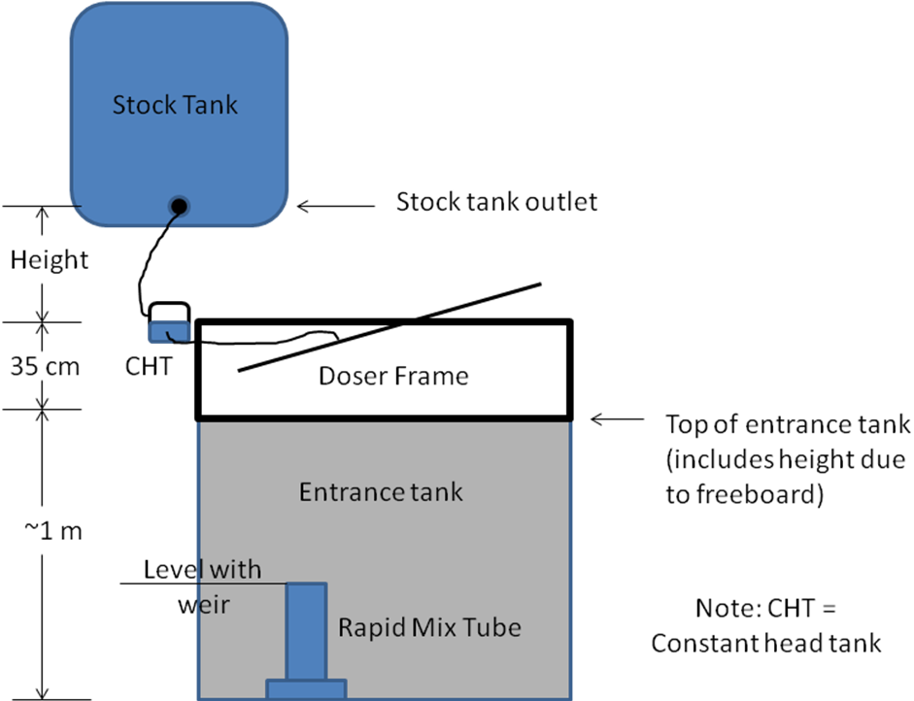

Figure 1. Critical elevations in the entrance tank
Where:
Height is the elevation of the stock tank outlet above the CHT float valve ( HL.FloatValveOrifice).
The calculated “Height” shown in the figure above ensures that the flow rate coming into the constant head can match the flow rate through the dosing orifice plus a factor of safety.

- Calibrating the dosing system
- Marking dosage concentrations
As previously mentioned, the Nonlinear Chemical Doser is a triple scale, orifice based doser which allows the plant operator to choose between three alum dosing ranges for added accuracy. The operator can choose between three orifice sizes which correspond to three dosing ranges, a low dosage (10-22 mg/L), a medium (20-44 mg/L), and a high dosage (40-88 mg/L). The triple scale is shown in the figure below:
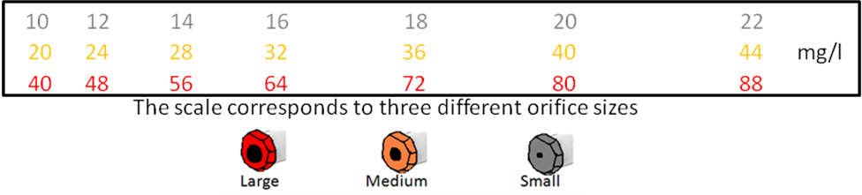

Figure 2. Nonlinear dual scale
The distances to these dosage concentrations are measured using the pivot point as the reference point, as seen in the figure below.
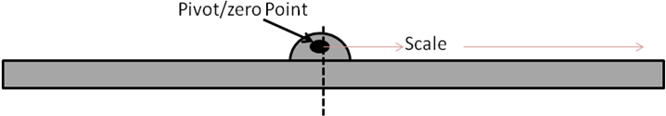

Figure 3. The scale distances as measured from the pivot point.
The scale distances correspond to a certain head or elevation height which drives the flow of alum. The scale then indicates the spot on the dosing arm which provides enough head to match the flow requirements of alum at that concentration point. The scale distances, the corresponding orifice sizes, and the required flow of alum are shown in the table below:

Triple Scale parameters:
The diameters of the orifices are D.CdcAlumOrifices.

- Adjusting the length of the chain.
With the slider moved to the zero dosage position (0 mg/L) on the dosing arm, adjust the length of the chain (or the mass of the float or of a counterweight) until the dosing arm is completely horizontal. This will serve as a base point from which the lever arm movements will start as plant flow increases.
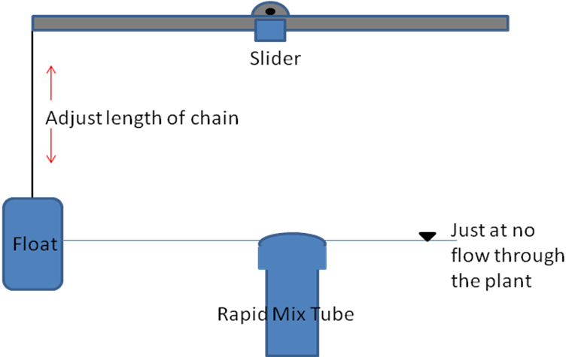

Figure 4. Adjusting the length of the chain
The water level in the entrance tank should be right at the point where there is no flow going through the plant. This is to ensure that as soon as water begins to flow into the rapid mix tube, the float will start to rise, causing alum to begin to be dosed.
- Setting the level of the constant head tank.
While the dosing arm is still horizontal and the slider is on the point of zero concentration move the constant head tank up or down until the water surface level is even with that of the orifice. As soon as the water surface is level with the orifice opening there will be no head driving flow, and there will be no alum flow through the orifice.
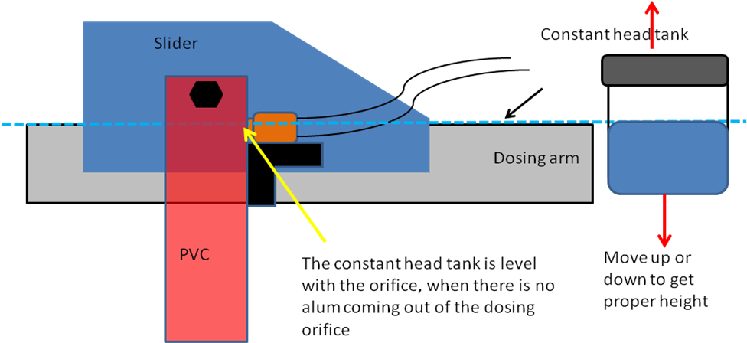

Figure 5. Leveling the constant head tank
- Minimum plant flow rate
The accuracy of the nonlinear chemical doser can be compromised due to surface tension if the plant flow is not high enough. Surface tension, which is a result of the cohesive nature of molecules on a water boundary, could compromise the effluent quality of water from the plant. As a result a minimum plant flow rate of Q.PlantMin is being recommended.
- Maintenance
- Cleaning of the apparatus/Clogging of the dosing orifice
Periodic cleaning of the parts of the dosing system is essential for proper operation. Additionally, the dosing orifice needs to be periodically checked to ensure that the opening not partially blocked or clogged.
- Sediment trap
A sediment trap between the stock tank and the constant head tank reduces clogging of the float valve and dosing orifice.
- Operational issues:
- Make sure the constant head tank cap has a small hole so that the air inside the tank is at atmospheric pressure.
2) Before using, ensure that there are no air bubbles in the dosing line. The presence of air bubbles causes inaccurate dosing. Disconnect the dosing tube and move it up and down to purge the lines of the bubbles.

Rapid Mix
Before influent water enters the rapid mixer, it must be treated with aluminum sulfate, which is often referred to as “alum”. Treatment with alum is an essential component of the water purification process, as it initiates the sequence of particle coagulation that makes flocculation effective.
Once turbid water has been treated with alum, the impurities in the water will begin to stick together, forming flocs. Only when all of the flocs are removed from the water will it truly be purified.
Rapid mix serves the function of distributing alum evenly throughout the raw water. The goal is to achieve small-scale mixing on the molecular scale to ensure that the alum permeates throughout all of the water coming in to the system to allow for optimal flocculation. The rapid mix system is a pipe with two orifice interfaces. One interface is for macro-scale mixing, which will have larger diameter orifices and less energy dissipation, and the other interface for micro-scale mixing, which will have smaller diameter orifices and more energy dissipation. Orifices are circular because a circle can be drilled easily. The rapid mix program calculates the required pipe size, InnerPipeDiameter, the diameter of the macro-mixing orifice, MacroMODiameter, the diameter of the micro-mixing orifices, MicroMODiameter, and the number of micro-mixing orifices, MicroMONumber.
The diameter of the pipe used for rapid mix is determined based on the plant flow rate and constraints on the total head loss desired in the system and for the macro-mixer. The diameter is rounded to the closest available pipe size. For this function, the values for the length of the pipe, L.RmPipe, the minor loss coefficient, K.Rm, and NU, the kinematic viscosity are already defined. Head loss for the macro-mixing is set to MacroMHConstraint. The total head loss throughout the plant is set at 40 cm. Thus, the total head loss in the rapid mix portion of the plant is the difference between the total head loss and the head loss from the rest of the plant. The micro-mixing head loss is thus the difference between this value and the macro-mixing head loss.
When sizing the micro-mixing orifice, an energy dissipation of 1 W/kg must be met to ensure sufficient mixing. Based on the value determined for the micro-mixer head loss, the diameter for the micro-mixing orifice is obtained.

Flocculation
The flocculator causes colloids (small particles) to collide and stick together to form larger aggregates (flocs) that can settle out more easily in the sedimentation tank. Particles collide more frequently in turbulent flow. Since the AguaClara plants use no electricity, the turbulence is generated by controlling the flow of the water around sharp bends. The water flows around a series of baffles. The baffles are in several channels to create a compact plant footprint and to minimize construction costs by maximizing shared wall space. The flocculation tank is also designed to have the same length as the sedimentation tank so the two unit processes can share a common wall. There are N.FlocChannels channels in the flocculator and each channel is W.FlocChannel wide (inner width, not including walls).
The particles must collide a certain number of times for them be large enough to settle out in the sedimentation tank but not prematurely in the flocculation tank. The target collision potential (a measure of the opportunities for collisions provided by the flocculator) that was set for the flocculator was CP.Floc. The actual total collision potential was CP.FlocTotal. Note that the design value for the collision potential can be significantly higher than the target because the number of flocculator channels must be an integer. The equation for the collision potential in each space between baffles is
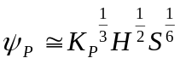 ()
where 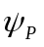= CP.Space is the collision potential between each baffle, 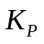= K.FlocBaffle is the head loss coefficient due to the 180° bend, H is water depth for vertical baffle or the channel width for horizontal baffles, and S is the distance between baffles.
The height of the floc tank wall was calculated by adding the head loss of the water through the flocculator to the height of the water in the inlet channel of the sedimentation tank and a freeboard height that was set as H.PlantFreeboard. The height of each floc tank wall measured from the inside bottom (i.e. not including the thickness of the slab) of the flocculator is H.Floc.
The total width of the floc tank (measured perpendicular to the direction of the channels), including the thickness of all the walls except the one shared with the sedimentation tank is W.FlocWithWalls. The total length of the floc tank is the same as the total length of the sedimentation tank. The total length of the floc tank including the thickness of the walls is L.FlocWithWalls. The floor of the flocculator (from the inside, not including the thickness of the bottom wall) is elevated Z.FlocTank from the floor of the sedimentation tank (from the inside, i.e. not including the thickness of the bottom wall).
The residence time in the flocculator is Ti.Floc. The average velocity in the flocculator is V.Floc.

Vertical Flocculator

"One of the design goals is to achieve the correct energy dissipation so that the particles collide frequently without breaking up from too much mixing. The target maximum energy dissipation rate at the design plant flow rate that was set for the flocculator was ED.Floc. The actual maximum energy dissipation in all channels except the last was ED.FlocChannelFirst. The maximum energy dissipation in the last channel is ED.FlocChannelLast. The equation used to calculate energy dissipation is:

"Horizontal FlocculatorIn a horizontal flocculator, the baffles are staggered from side to side. The length (from side to side) of the baffles is L.FlocBaffleLower. The width of the baffles (from top to bottom) is W.FlocBaffle. The width is shorter than the height of the floc tank to allow a path for water flow in case the plant becomes accidentally overloaded with water.The thickness of the floc baffles is T.FlocBaffle. If the thickness of the baffles is not the desired thickness, the facility should be redesigned with the correct baffle thickness.The baffles must be made of a rigid water proof material. They must containing sufficient reinforcement so that they withstand normal maintenance activities. They could be built as integral sections of the channel walls and could even be built using the same construction technique as the channel walls.The spacing between baffles (not including the baffle thickness) in all the channels except the last is S.FlocBaffleFirst. The spacing in the last channel (except in the first and last spaces of the channel) is S.FlocBaffleLast. The spacing in the last channel is slightly different to maintain the flow pattern and accommodate the width of the inlet channel to the sedimentation tank. The center to center spacing (which includes the baffle thickness) in all the channels except the last is B.FlocBaffleFirst. The center to center spacing in the last channel (except in the first and last spaces of the channel) is B.FlocBaffleLast. The number of baffles in the all the channels except the last is N.FlocChannelBafflesFirst. The number of baffles in the last channel is N.FlocChannelBafflesLast. The total number of baffles in the flocculator is N.FlocBaffles.The width of each channel (not including wall thickness) is W.FlocChannel. It was calculated by multiplying the space between the baffles by Pi.JSOptimal.The channels are connected by an open space that has the same width as the space between baffles, W.FlocPort0.One of the design goals is to achieve the correct energy dissipation so that the particles collide frequently without breaking up from too much mixing. The target maximum energy dissipation rate at the design plant flow rate that was set for the flocculator was ED.Floc. The actual maximum energy dissipation in all channels except the last was ED.FlocChannelFirst. The maximum energy dissipation in the last channel is ED.FlocChannelLast. The equation used to calculate energy dissipation is:

General Flocculation Design
Gate valves are placed at the base of every other channel in the flocculator (both horizontal and vertical) at-grade to allow for draining. Additionally, the design requires a drain in the first and last channel of the flocculator, so if there is an even number of channels, the first two channels (the ones closest to the entrance tank) will each have a valve. The nominal diameter of the valve, ND.FlocValve, is calculated so that the flocculator tank can be drained in less than Ti.FlocDrain. The valves that need to handle the highest flow rates are the valves that drain two channels. All of the valves are then set to that size. The equation for the minimum valve diameter is given by
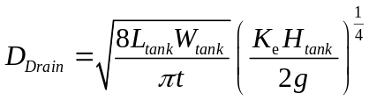 ()
where
This design requires N.FlocValves drain valves for the flocculator. An ND.FlocValve diameter coupling is embedded in the flocculator wall. A short nipple and an adaptor are used to connect to the valve. We recommend connecting an elbow to the effluent of the valve to deflect the water into the drain canal.
Since the center of the valve is aligned with the floor of the flocculator, slopes are required in the floor of the tank. The slopes have a width equal to the diameter of the valve, ND.FlocValve, and a depth equal to half the diameter, H.FlocSlope. Thus, the valve is placed at-grade with a slope of 30 degrees. In the event that a 30 degree slope causes the slope to be longer than the space between baffles, the length of the slope is set to be 5 cm away from the nearest baffle. If the distance the slope extends into the channel is longer than the spacing between baffles, the slope would extend through a baffle. To correct this problem, the distance the slope extends into the channel will be set to a distance of 5 cm from the nearest baffle.

Sedimentation

General Description
The AguaClara sedimentation tank is a vertical flow sedimentation tank in which settling is achieved through low up flow velocity and plate settlers. The most important parts of the tank are the Inlet Channel, Inlet Manifold, Sludge Drain, Lateral Slopes, Plate Settlers and Effluent Launder and Effluent Channel (see Figure 1).

Maintenance
The AguaClara sedimentation tanks are designed to be maintained by one or two operators. The tanks are designed with the operator in mind. A sedimentation tanks can be isolated from the rest of the plant for cleaning without using any valves. The inlet and outlet connections are simple capped and then the tank can be drained. Each sedimentation bay is constructed so that it can be disassembled without affecting adjoining bays. The launder pipes, plate settlers, plate settler support frame, inlet manifold and sludge drain cover can all are removed by an operator. The only tool required is a screwdriver to loosen the band clamps on the launder and inlet manifold. Daily maintenance to control sludge levels is done by opening the sludge drain valve (without electricity). A more extensive tank cleaning is required to remove sludge build up especially after periods of very high turbidity.
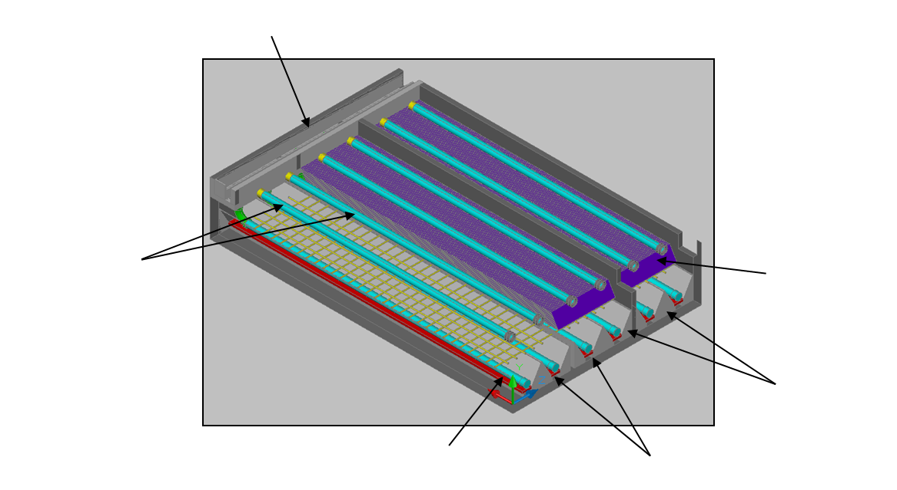
Plate Settlers
Lateral Slopes
Sludge drain
Inlet Manifold
Launders
Inlet Channel

Figure 6. Typical AguaClara Sedimentation Tank

Input Values
The input values used for the sedimentation tank design are shown in the following table.

Table 1. Input Design Values
Plant Flow rate | Q.Plant
Number of Sedimentation Tanks | N.SedTanks
Number of bay per Sedimentation Tank | N.SedBays
Width of plate setters | W.SedPlate
Length of sheet used to make plate settlers | L.SedPlateSheet

Basis of Design Inputs
In general, sedimentation tank design is based on three mayor parameters that control its adequate performance, up flow velocity inside the sedimentation tank, capture velocity of the plate settlers and energy dissipation rate inside in its components. Research done by the AguaClara team has provided guidelines to use certain values that have proven adequate for the optimum performance of the sedimentation tank.
The following table shows that basis of design inputs used by AguaClara to design the sedimentation tank.

Table 2. Basis of Design Inputs Values
Up flow velocity | V.SedUpBod
Capture velocity | V.SedC
Energy dissipation rate | ED.Floc

Hydraulic Design

Inlet Channel
The main objective of the inlet channel design is to transport flocs from the flocculation tank to the inlet manifolds. It must prevent settling in the channel and it must not break the flocs. To prevent floc breakup the maximum energy dissipation rate (εMax) inside the inlet channel must be less than or equal to the maximum energy dissipation rate in flocculation (ED.Floc). The location of the maximum energy dissipation rate is downstream of the entrance to the inlet channel where the water takes a 90° bend as it leaves the flocculator. The minimum channel area required to achieve this energy dissipation rate is estimated using the following equation.
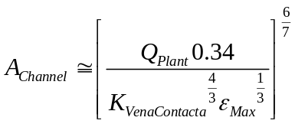 ()
Where
- A_{Channel} = Area of the inlet channel
- Q_{Plant} = Plant flow
- K_{VenaContracta} = Vena contracta coefficient (0.62)
- ε_{Max} = Maximum Energy dissipation rate of the flocculator

- The inlet channel is designed with a series of constraints including:
- wide enough to contain the couplings that connect to the inlet manifold
- deep enough so the channel wall can have a ledge to support the effluent launder pipes
- shallow enough for easy access to the bottom of the channel
- area large enough to prevent floc breakup
The diameter of the couplings embedded is taken into account to make sure that they will fit in the channel. In case the couplings do not fit in the initial width calculation, a new width is calculated according to the couplings requirements. The energy dissipation rate in the flocculator, ED.Floc, is high enough to meet scour velocity. The channel is designed to have H.PlantFreeboard of freeboard.
The energy dissipation rate in the Inlet Channel is equal to ED.SedInlet and the average velocity at the beginning of the inlet channel for the current design is V.InletChannel.
The following table shows the dimensions of the inlet channel.

Table 2. Inlet Channel Dimensions
Length | L.Channel
Inside Width | W.InletChannel
Height (includes freeboard) | H.InletChannel
Water Depth | HW.InletChannel

Inlet Channel Weir
The main function of the weir in the inlet channel is to divert water bypassing the sedimentation tank. This operation can be necessary in maintenance operations or in case of a failure in the flocculation process. The type of weir depends on the plant design flow rate. Perpendicular weirs are used for low flow plants and parallel weirs are used for high flow plants.
Parallel weir
Perpendicular weir
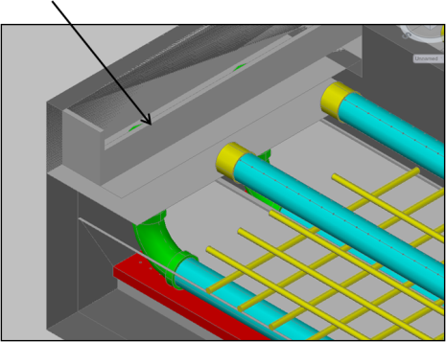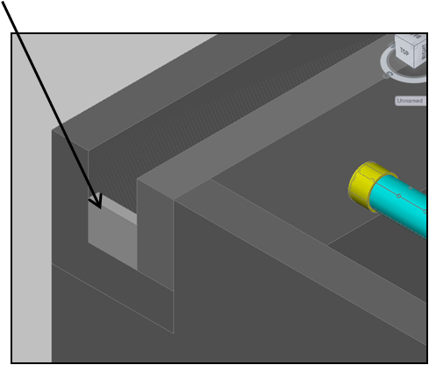

Figure 7. Inlet Channel Weirs for a high flow rate facility showing a parallel weir (left) and for a low flow rate facility showing a perpendicular weir (right). The weirs provide a mechanism to dump poorly flocculated water without contaminating the sedimentation tanks.
The width of the weir is defined by the type of weir. Perpendicular weirs have the same width as the inlet channel and the width for parallel weirs is equal to the length of the inlet channel. The height of the weir is estimated by the following equation
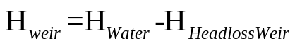 ()
The dimensions and head loss of the weir are shown in the following table.

Table 3. Inlet Channel Type, Dimensions and Head loss
Type of Inlet Weir | PerpendicularParallel with the channel
Length of Inlet Weir | W.SedWeirInlet
Height of Inlet Weir | H.SedWeirInlet
Head loss across the Inlet Weir | HL.SedWeirInlet

It should be noted that if the inlet channel has a parallel weir, the inlet channel width includes the width of the weir exiting channel.

Inlet Manifold
The inlet manifold is a pipe that transports water from the inlet channel to the bottom of the sedimentation tank. Water is distributed uniformly through ports in the bottom of the manifold (see Figure 8).
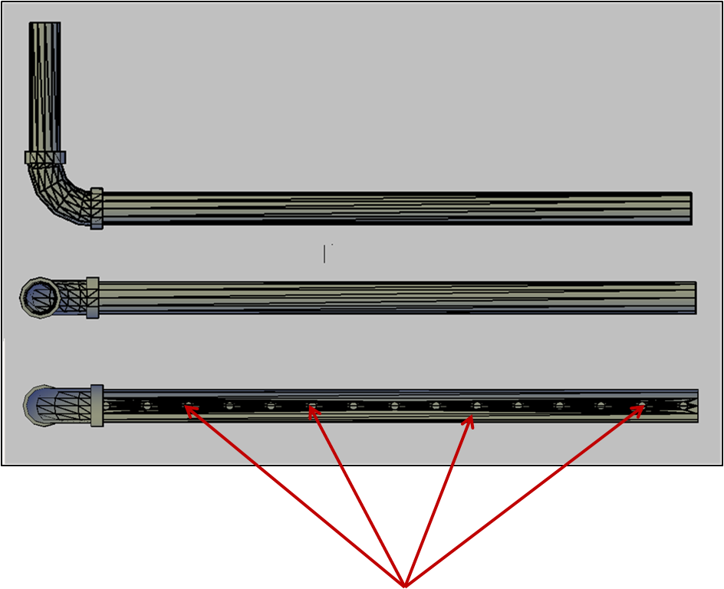
Ports

Figure 8. Inlet Manifold

The main constraints in the manifold design are low energy dissipation rate to prevent floc break-up and uniform velocity from the ports. The pipe diameter is sized to have an energy dissipation rate near the pipe entrance that is lower than the energy dissipation rate in the flocculator. The minimum diameter is given by the following equation.

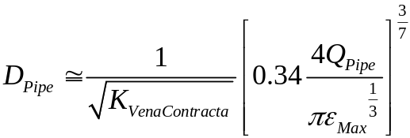 ()
- D_{pipe}= pipe diameter
- Q_{pipe} = Flow per sedimentation tank
- ε_{max} = Maximum energy dissipation rate
The number of ports in the inlet manifold is estimated by dividing the inlet manifold length by the spacing between ports. Currently the spacing between ports is set to B.SedManifoldPort. The optimum port diameter of the manifold should have the sum of the areas of the jets flowing out the ports equal to the area of the pipe. Port diameter is estimated to meet this requirement taking into account available drilling sizes.
The dimensions of the inlet manifold design are shown in the following table.

Table 4. Inlet Manifold Dimensions
Nominal Diameter | ND.SedManifold
Port diameter | D.SedManifoldPort
Number of ports | N.SedManifoldPorts
Distance between ports | B.SedManifoldPort
Length | L.SedManifoldPipe
Manifold Elevation (see Figure 9) | Z.SedManifold
Manifold/Drain Cover separation (see Figure 9) | S.SedManifoldBetween

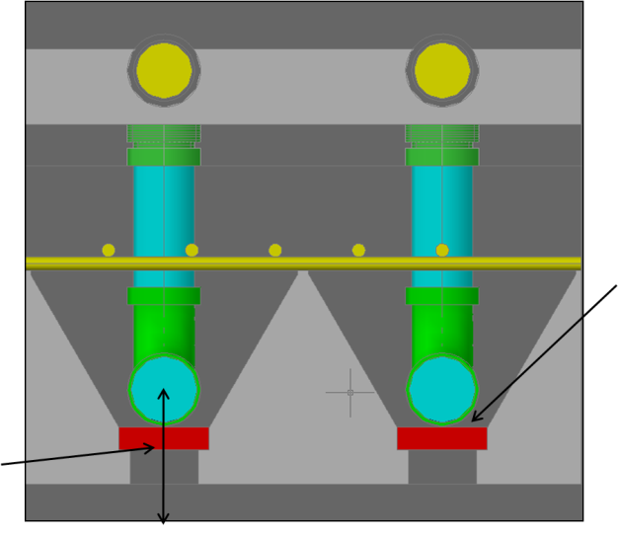
Manifold/Drain Cover Separation
Manifold Elevation

Figure 9. Manifold Important Elevations

Sludge Drain
The sludge drain is a rectangular channel which drains settled floc out of the sedimentation tank during purging. This channel is designed to be able to drain one sedimentation tank bay in Ti.SludgeDrain. On top of the drain channel there is a drain cover. The purpose of this cover is to provide a uniform suction force on the settled sludge in order to prevent sludge accumulation at the beginning of the drain.

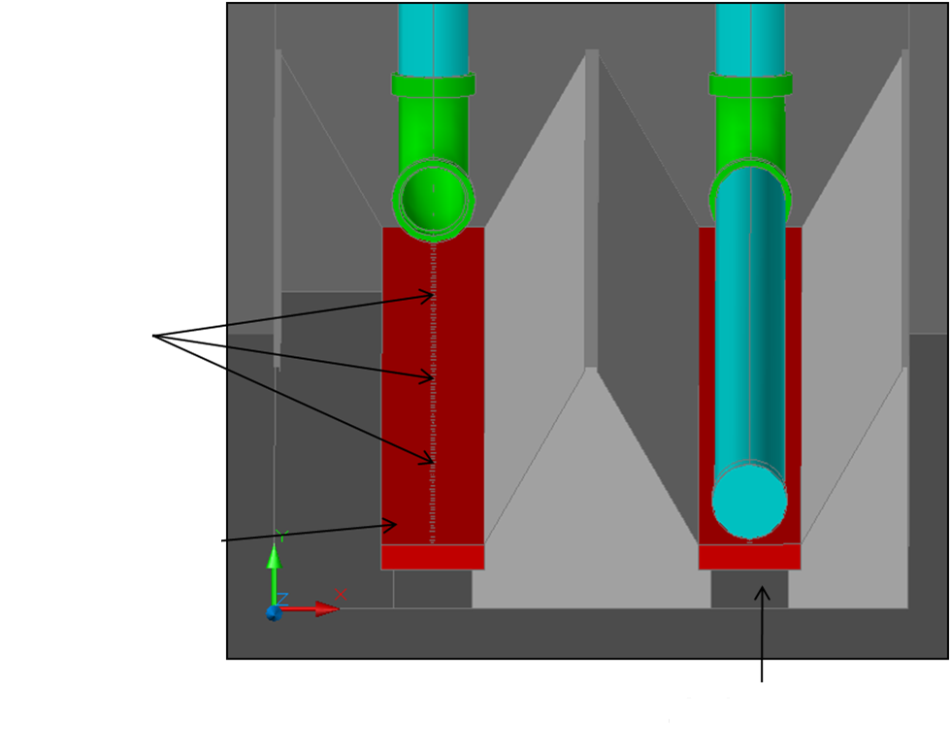
Sludge Drain
Drain Cover
Ports

Figure 10. Sludge Drain
The dimensions of the Sludge Drain are shown in the following table.

Table 5. Sludge Drain Dimensions
Width | W.SedSludge
Height | H.SedSludge
Drain cover width | W.SedDrainCover
Drain cover thickness | T.SedSludge
Drain Cover port diameter | D.SedSludgeOrifice
Drain Cover port spacing | B.SedSludgeOrifices
Number of Sludge Orifices | N.SedSludgeOrifices

Sedimentation Tank
The objective of the sedimentation tank is to provide an adequate environment for the flocs to settle. Settling is done in two stages; the first is in the sedimentation tank and the second in the plate settlers. The sedimentation tank has lateral inclined walls. The main purpose of these sloped bottoms is to increase up-flow velocity near the inlet manifold so that settled flocs can be re-suspended to create a floc blanket. The sludge drain is designed to remove sludge and to drain the tank for any tank maintenance.
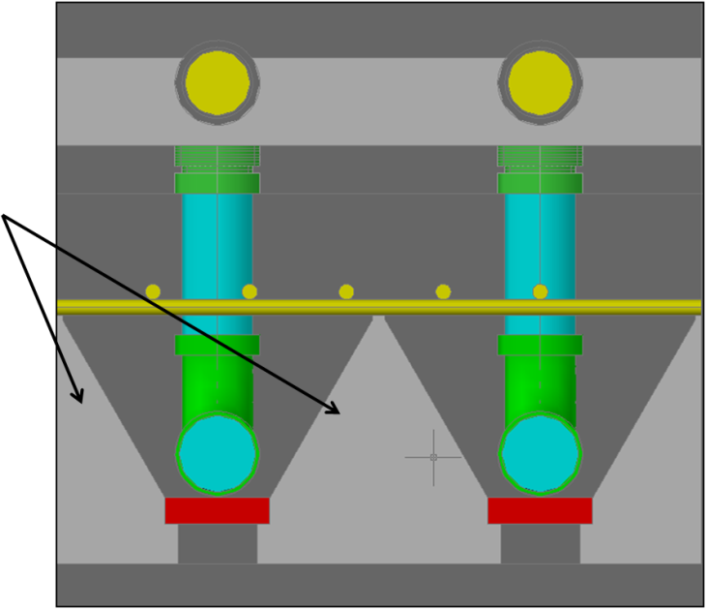
Lateral Inclined Walls

Figure 11. Typical Sedimentation Tank
The value of the up flow velocity at the top of the sedimentation tank is shown in the following table.
Up flow Velocity | V.SedUpBod

The dimensions of the sedimentation tank as shown in the following table.

Table 6. Sedimentation Tank Dimensions
Tank bay width | W.SedBay
Tank bay length | L.Sed
Height of inclined walls | H.SedBayDivider
Width of inclined walls | W.SedSlope
Angle of inclined walls | AN.SedSlope

The inclined walls have the same angle as the plate settlers. Their main goal is to have flocs slide down to the bottom of the sedimentation bay where they can be resuspended.

Sedimentation Drain Design
The size of the valve used to drain the sedimentation tank, is based on a user input time, Ti.FlocDrain. Each bay in every sedimentation tank must have a valve of its own. This design requires N.SedValves at a nominal diameter of ND.SedValve.
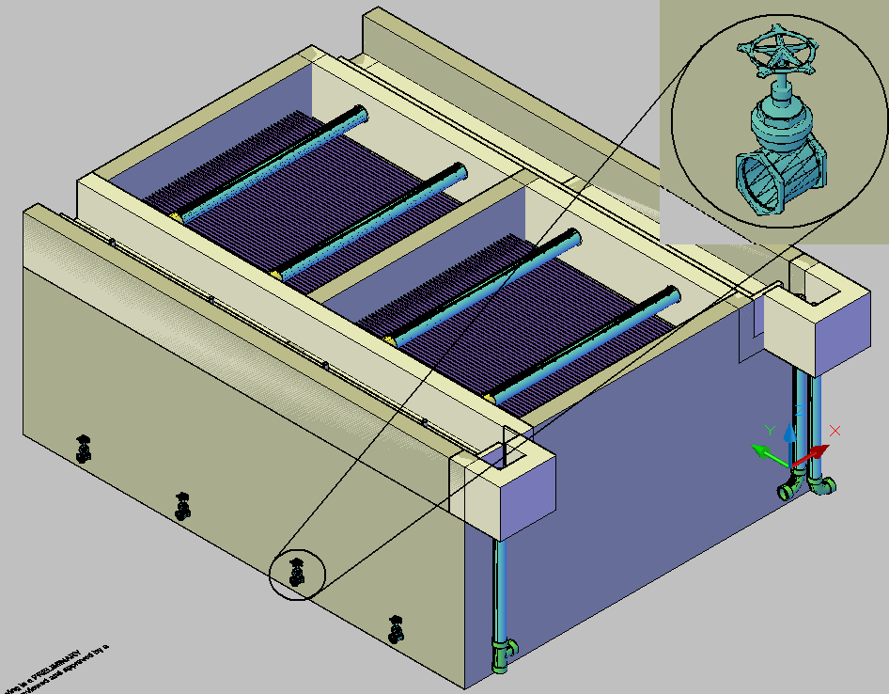
A short pipe nipple can be attached to coupling that is embedded in the wall of the tank. A pipe adapters can be used to connect to the drain valves.
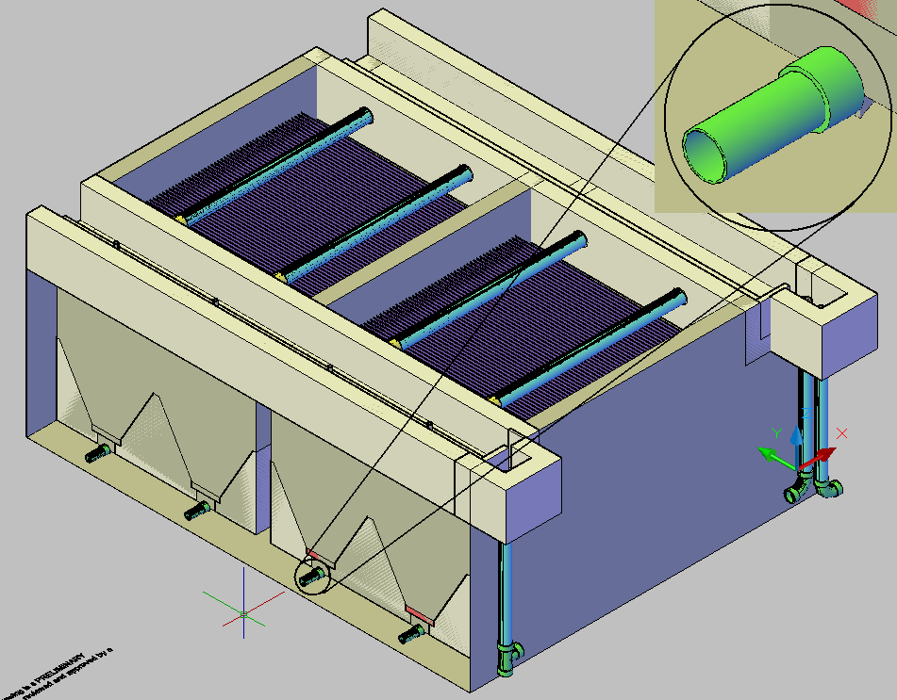
The drain valves are centered at the top of the slab and thus slopes are required in the floor of the tank to align with the valve invert. The slopes have a width equal to the nominal diameter of the valve, ND.SedValve, and a depth equal to half the diameter, H.SedSlope.
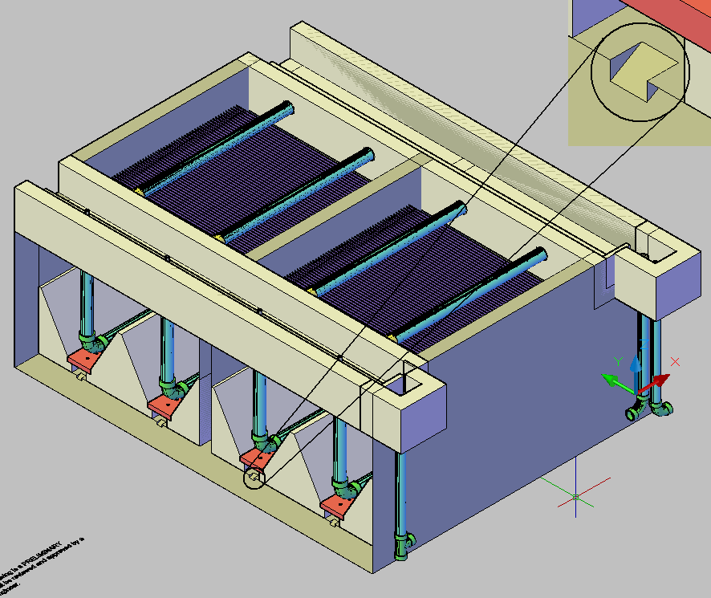

Plate Settler Pipe Frame
Plate Settler As water flows up through the bottom of the sedimentation bay, it flows through the plate settlers. The lamella are corrugated plates oriented set at an angle of AN.SedPlate from the horizontal. Their purpose is to capture small floc particles. The flocs settle onto the lower plate and then slide down to the bottom of the sedimentation bay. The lamella are W.SedPlate wide and L.SedPlate long.

Effluent Launder
The number of orifices in each launder is N.SedLaunderOrifices.
The diameter of the sedimentation tank launder is ND.SedLaunder.
The elevation of the sedimentation tank launder is Z.SedLaunder.
The number of launders per sedimentation bay is N.SedLaunders.
The number of launders in the plant = N.Launders.
The length of the sedimentation tank launder is L.SedLaunder.
The diameter of the sedimentation tank launder orifice is D.SedLaunderOrifice.
The distance between the centers of the orifices is B.SedLaunderOrifices.

Exit Channel
The water flows from the launder into the exit channel. Like the inlet channel, the exit channel is a rectangular channel that is W.ExitChannel wide and the height of the exit channel is H.ExitChannel. The channel thickness is T.PlantWall.

Inlet and Exit Channel Weirs
In both the inlet channel and exit channel there are weirs that regulate the water height in the plant. There are two possible weir designs:
The weirs span the length of the entire inlet or exit channel, and run parallel to the channel.
The weirs span the width of the channel and run perpendicular to the channel.
In our case, the weirs behave as described in (1).
By calculating the head loss over the weir given the plant flow rate, the height of the weir can be determined. The height of the water in the plant is then equal to the height of the water flowing over the weir. The weir in the exit channel regulates the height of the water in the sedimentation tank (and thus the rest of the plant) during normal plant operation. Its height measured from the bottom of the channel is H.SedWeirExit and its width is W.SedWeirExit. When the water coming from the flocculator is not suitable for the flocculator, the water can be dumped before going into the sedimentation tank. In this case the weir in the inlet channel regulates the height of the water in the flocculator. The width of the inlet weir is W.SedWeirInlet and the height of the inlet channel weir is H.SedWeirInlet.

Inlet and Exit Control Boxes
The inlet control box provides a path to dump water when flocculation fails to protect the water in the sedimentation tank. The control boxes cantilever off the side of the sedimentation tank. The tank contains a pipe which will connect to an exit channel for wastewater. This pipe has nominal diameter ND.PltWeir and length inletweirpipe.length. The pipe has a tee on it with the same diameter. The tee takes in water from the inlet tank and the connecting pipe from the exit tank and sends it to waste.
The exit tank takes water from the exit channel after it has gone through the sedimentation tank. The dimensions of the exit tank are stored in echanneltank.dim. The exit tank has two pipes: one which sends clean water to the distribution center and one which sends water through a connecting pipe to the inlet tank pipe and then out to waste. Both pipes have nominal diameter ND.PltWeir and length exitweirpipe.length. The connecting pipe from the exit tank pipe to the inlet tank pipe has the same diameter and length connectingpipe.length .

Plant Construction General Requirements
Building a roof to cover the plant to reduce UV damage to the plastic components.
Chemical storage room
Bathroom facilities
Disposal method for sludge and wasted water.

List of AguaClara Plants
A complete list of the AguaClara plants that have been constructed can be found at https://confluence.cornell.edu/display/AGUACLARA/Project+Sites. This site contains links to each plant’s wiki page, as well as a map showing the locations of the plants.

Appendix
- Calibrating plant head loss
The maximum flow rate the plant has been designed to handle is Q.Plant; this value serves as a design input which will assist in sizing the dosing components. The following section will provide a guide for measuring the plant flow rate at any time in an AguaClara plant by simply looking at the water level height in the entrance tank. This is essential in the operation of the doser since a certain flow of alum is required at different plant flow rates. The only way to verify if the doser is providing accurate dosages is to know the plant flow rate and the corresponding alum flow rate.
The majorities of the head losses through the plant are minor head losses and as such can be approximated by the following formula.
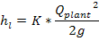
Where:
= minor head loss through the plant, m
A constant,
= plant flow rate,
A critical step involved in being able to find the plant flow rate is to first find the value of the constant K in the minor loss equation above. The head loss between the entrance tank and the sedimentation tank exit channel is HL.PlantTotal. This total head loss value will have to be calibrated when a plant is first being made operational. The mechanism by which the plants head loss is adjusted is by increasing or decreasing the number of orifices drilled into the micro mix plate in the rapid mix tube (shown in the figure below). The following steps will help in determining the K parameter, measuring the plant’s flow rate, and adjusting the plant head loss to match the design value of 40 cm.
Step 1
The micro mix orifice plate needs to be drilled with an initial number of holes before initializing the measurements of the plant flow rate. The location of the micro mix plate is shown in the figure below. In order to initiate testing, drill N.orifices D.DrillBit inch holes to initiate the testing. Install this orifice plate on the rapid mix (R.M.) tube in the entrance tank.
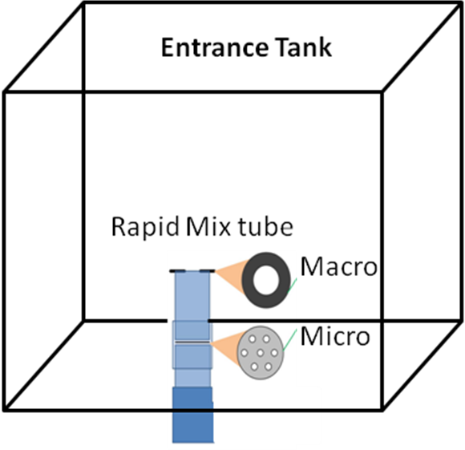
Figure: The location of macro and micro orifice plates in the Rapid Mix Tube (RMT)
Step 2 – Measure the plant flow rate
Sub steps:
- Drain the entrance tank by removing the pipe nipple in the drain.
- Turn on the flow of water into the entrance tank
- Plug the drain with the pipe nipple
- Measure the change in depth in the entrance tank over some interval of time to get the current plant flow rate coming into the entrance tank. Shown in the figure below.
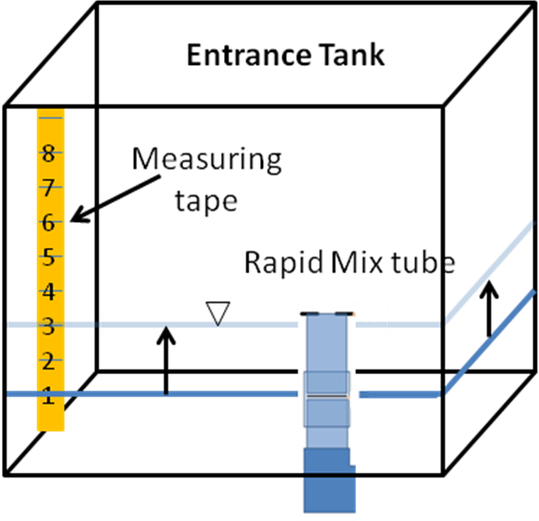
Figure: Calculating the flow rate by measuring some volume over time
For example: If the entrance tank is 1.0 m by 1.0 m, and the water level went from 0 cm to 15 cm on the measuring tape in 45 seconds, then the plant flow rate is:
Q = (1.0m*1.0m*0.15m)/45s*(1000 L/m^3) =3.33 L/s
Step 3 – Measuring the plant head loss
Keep the flow through the plant constant at the measured flow rate from Step 2. The water level will equilibrate in the entrance tank. Once a steady state water level has been reached, measure the head loss through the plant by measuring the height of the water above the rapid mix tube. This assumes that the top of the rapid mix tube is exactly level with the exit weir in the exit channel. Check this by turning off the flow through the plant and recording the “no-flow” water level in the entrance tank. If the water level inside the rapid mix tube is lower than the water level in the entrance tank, then the rapid mix tube must be shortened.

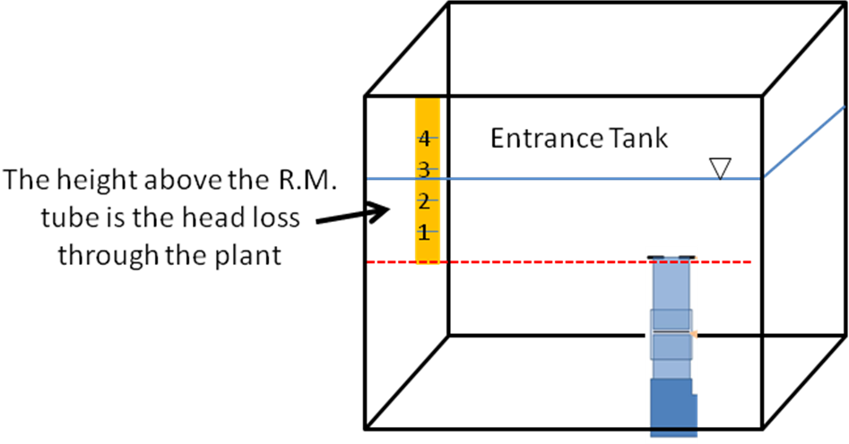
Figure: The measured head loss through the plant
Step 4
Enter in the values of the plant flow rate and the measured head loss through the plant into the attached MathCAD file called “Plant head loss adjustment.” Enter in the value of the measured flow rate and the height of water above the rapid mix tube. The MathCAD file will generate the number of additional orifices that need to be drilled in the plate initially used.
Step 5
Drill the number of specified orifice holes into the micro mixing plate, as given in the MathCAD file. Redo steps 2 and 3 with the newly drilled micro mixing plate installed. Enter in the values for the measured flow rate and the measured height of water above the rapid mix tube into the excel document labeled “Plant Flow table.” The excel document will give an increment of heights above the rapid mix tube and equate them with a plant flow rate. Ensure that at HL.PlantTotal head loss through the plant, the plant flow rate is Q.plant L/second. The table given in the excel file can be printed out and can be referenced to find the plant flow rate at any measured height above the RM tube.

Materials List Documentation Testing
Test:Q.plant
“Q.plant” should be inserted here

The number of bays set by the user can change in the design process in order to create sedimentation tanks that aren’t too long for reasonably sized inlet manifolds.

